Digital care

Design Document

|  |  |  |  |  |
| --- | --- | --- | --- | --- |
| **Document History** | | | | |
| **Version** | **Date** | **Author** | **Section** | **Changes** |
| 0.1 | 28 Nov 2014 | Kaushik C S, Ritesh Jha | All | Initial version |

|  |  |
| --- | --- |
| **Author** | Kaushik C S,  Ritesh Jha |
| **Approved by** |  |
| **Email Id** | [Kaushik.murthy@philips.com](mailto:Kaushik.murthy@philips.com),  Ritesh.jha@philips.com |

CONTENTS

1. DEFINITIONS & ABBREVATIONS 3

2. INTRODUCTION 3

2.1 Purpose 3

2.2 Scope 3

2.3 Target Audience 3

2.4 References 3

3. ARCHITECTURAL ANALYSIS 4

3.1 Product Overview 4

3.2 System Context 4

3.2.1 App to CDLS communication 4

3.2.2 App to Janrain communication 4

3.3 Design Method 4

4. STATIC DESIGN 6

4.1 Layering Model 6

4.1.1 View 6

4.1.2 Controller 6

4.1.3 Model 6

5. Decomposition / Sub Systems 7

5.1 Configuration Manager 7

5.2 User Registration 7

5.3 Product Registration 7

6. UI/UX Design 8

6.1 Android Design 8

# DEFINITIONS & ABBREVATIONS

|  |  |
| --- | --- |
| DI | Digital Innovation |
| MVC | Model View Controller |

# INTRODUCTION

This document provides architecture and top level design for Digital care application/library developed on Android. The various building blocks of the application are depicted and in the document.

## Purpose

This document serves as the base document for designing the individual components and implementation.

## Scope

This document covers the design aspects of Digital care mobile App.

## Target Audience

*PIC – DI development team*

## References

|  |  |
| --- | --- |
| Design | Care in apps – design specifications v1.pdf |
| Overview - Feature | Digital consumer care app functionality overview_updated.xlsx |

# ARCHITECTURAL ANALYSIS

## Product Overview

The main functionality of this product/library is to cater common features used across different applications. This application/library can be reused by other project with minimal development changes.

## System Context

The following diagram shows the eco system of Digital care application.

The Digital care application/library will talk to different services as shown in the below picture.

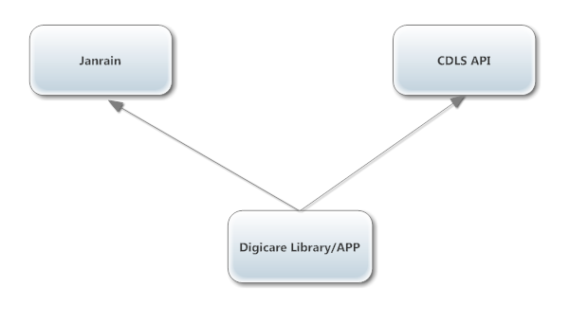

Figure 1: Digital care eco system

### App to CDLS communication

Digital care application/library will communicate with CDLS web services to fetch Contact us (Email, Phone number, etc.) information depending on the product and country.

### App to Janrain communication

Janrain is used to user registration/login and product registration. Janrain provides SDK which exposes the interfaces to communicate with Janrain server.

## Design Method

The design used Object Oriented concepts which are supported by Android.

The app follows the layered approach. Following rules are enforced for how the layers interact with each other.

* **One way interaction (Top to down)**: Higher level layers can interact with layers below, but lower layers cannot interact with layers above. This is to avoid circular dependencies between layers.
* **Strict interaction**: Layers can only interact with layers below. This will make sure that modifications in one layer will only affect layers above.

The focus of the design is to reduce the amount of traffic from App to various systems in the network. The amount of threads needed to communicate must be minimised in order to optimize resources and to enable app to work with lower end mobile devices.

# STATIC DESIGN

## Layering Model

The figure below shows the top level structure of Digital care library. It is a three layer architecture that conforms to MVC architecture pattern. User Interface part includes either an activity or a fragment or a custom view.

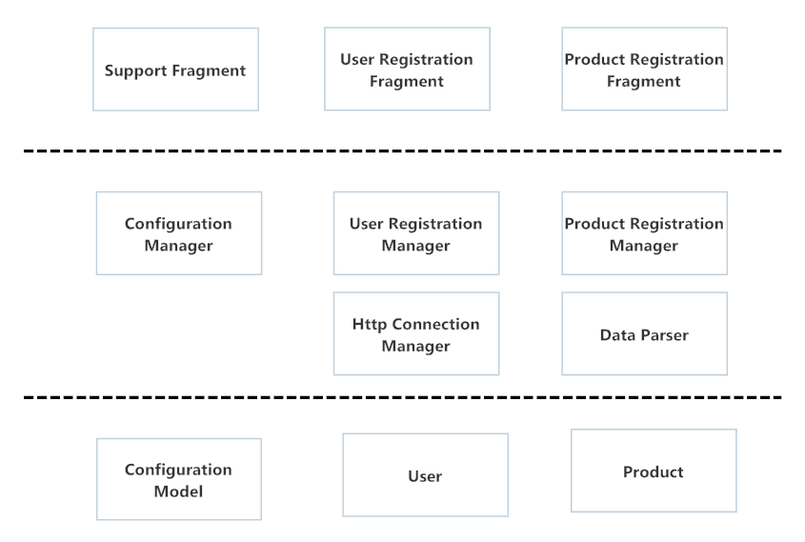

Figure 2: High level software decomposition

### View

View is the visual representation of data on the screen. Each screen in Digital Care app/library is considered as view or fragment or activity.

### Controller

Controller does data handling between the view and the model.

### Model

Model is the layer that consists of data.

# Decomposition / Sub Systems

The layered design is decomposed into following major paradigms.

## Configuration Manager

Below picture (Fig 5.1.1) depicts how the configuration manager interacts with user interface.

Configuration Manager is a singleton class which will have the Application configuration model.

Digital care library/APP will have an XML or a JSON file stored in the assets folder or project folder.

User interface will talk to Configuration Manager to get the APP configuration model.

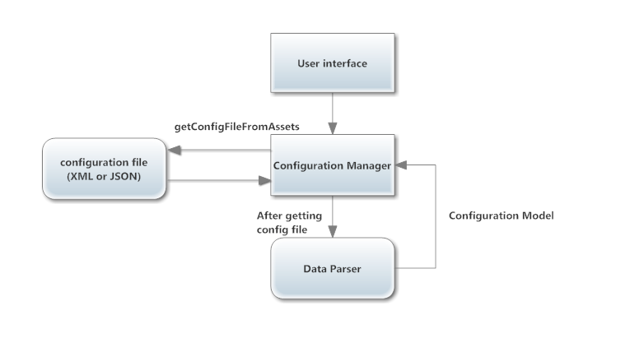 Fig 5.1.1

## User Registration

## Product Registration

# UI/UX Design

## Android Design

Below diagram (Fig 6.1.1) represents the UI/UX design approach for designing the screens which can be configured by a developer.

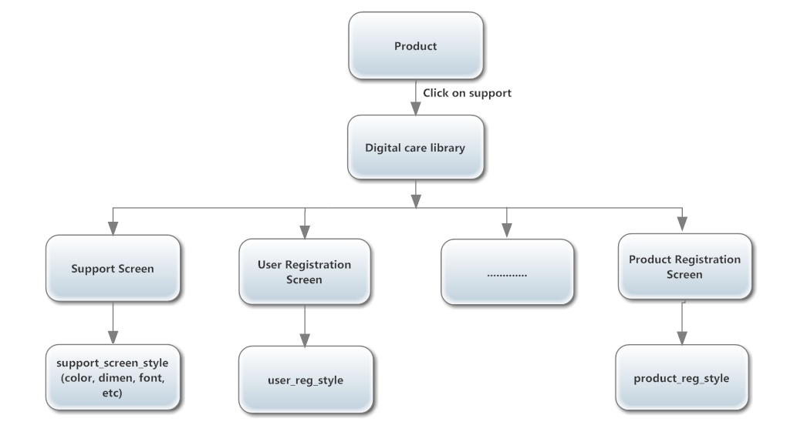

Figure 6.1.1

Each product will have a support screen; on click of the support screen Digital care library will get invoked.

Each screen will have a separate style so that a developer can modify the style for each screen depending on the design.